 |  | 

Time for War Fitness – Warrior Race
OCCCR Active Living Challenge

HOST: Humber College, Lakeshore Campus

PRESENTED BY: Jesse Bruce, Time for War Fitness
DATE: Saturday, September 28, 2013
TIME: 9:30am Registration, 11:00am Event Starts

LOCATION: 3199 Lakeshore Blvd. West, Toronto ON M8V 1K8
COST: $20/student (invoiced after the event) (We are only taking 75 students)

ENTRY INCLUDES: Warrior Race, Lunch & Participation T-shirt

REGISTRATION DEADLINE: Friday, September 20th @ 3:00pm

EVENT DESCRIPTION: Generally, a TFW Warrior Race consists of 3 to 5 rounds of various body weight exercises, the “Warrior Camp”, followed by a 5 km obstacle race. The TFW Warrior Race is based on a team and family environment. Persons from all fitness levels are encouraged to participate. The goal is to improve one’s own fitness level, whether an elite athlete or a fitness beginner.
Many different fitness components are put into each of the rounds of body weight exercises including: strength, cardio, speed, agility, power, endurance, and stamina. This is what is referred to as the “Warrior Camp”. The “Warrior Camp” is unlike a boot camp in the sense that the instructors and race staff act as motivators, not drill sergeants. Instructors will motivate, encourage and challenge participants to push themselves to their own limits. Participants needing to take a break are also encouraged to do so.
Following the 20 to 30 minute “Warrior Camp”, participants will embark on a 5 km timed obstacle race. Along the race path, participants will take part in various equipment challenges (ie. pulling power sleds, carrying tires overhead, sledge hammer slams, carrying pails full of rocks, carrying cinderblocks, battle rope slams, etc.) and exercises (push-ups, jump squats, lunges, etc). The majority of equipment obstacles will be set up in 2 main areas however the other exercises will be spread out along the way. Additional obstacles that participants may face include: monkey bars, climbing ropes, walls and an inverted chin-up set-up. Although encouraged to complete all race components, participants may choose to skip obstacles that they feel are too challenging or unsafe. There will be an alternative exercise to be completed in high-challenge areas.
Through this program of healthy competition, participants will be encouraged to reach their personal fitness goals while having fun in a safe, controlled setting.
SAMPLE EVENT VIDEO: http://youtu.be/3wDgIhfoMJg
SCORING: Scoring is completed the same way for OCAA Cross Country:
- Participants may run as individuals or as a co-ed team (2 males, 2 females).
- Schools are encouraged to send at least 1 complete team to this event.
- Individual race times and placing will be recorded.
- The first 2 males and the first 2 females from each co-ed team to finish the race will make up the team’s overall score. The team with the lowest collective placing will be declared the winner. (ie. Male 1 - 1st, Male 2 - 5th, Female 1 - 4th, Female 2 - 7th makes a total of 17 points (1+5+4+7).
There is no cap as to the number of participants who can represent a single team. This gives beginners a chance to participate without feeling that they may negatively affect the team score. (ie. 30 people could enter from Humber College, only the first 4 times will count toward the team score.)

PARKING: Parking is included. A limited number of parking spaces are available in the lot behind the AB Building. Teams are asked to carpool wherever possible.

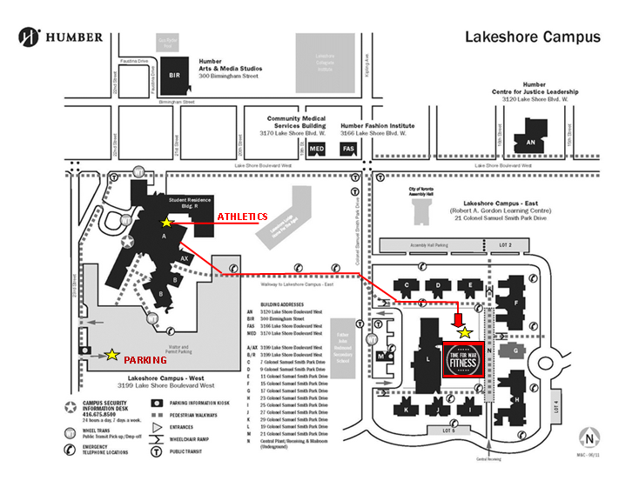

VENUE/ROUTE: The event will take place outdoors behind the L building. Change rooms, washrooms, water fountains and showers are available for use inside the Lakeshore Athletics Facility, AB Building. Depending on the number of participants wishing to use showers after the race, lines may begin to form.

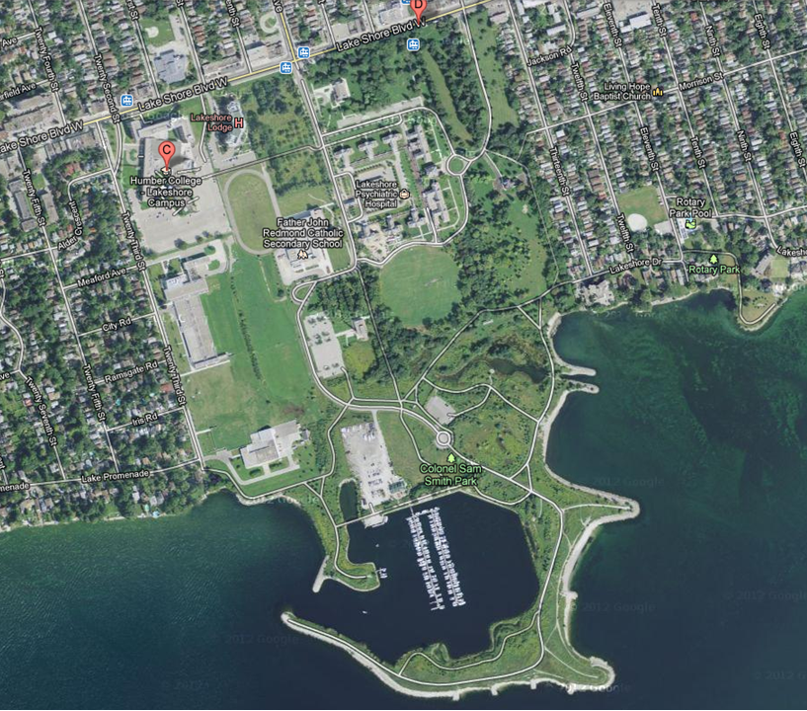

CLOTHING: Participants should wear comfortable athletic clothing and running shoes for the duration of the run. Participants are asked to come dressed appropriately for activity and for the weather. All participants should bring a change of clothes for after the race, and a plastic bag to carry wet/dirty gear home in.

INCREASE STUDENT INTEREST: To increase the interest for this event, it may be beneficial to cover the students’ travel costs (bus, van, etc.). It may also be a good idea to subsidize their event entry fee. Feel free to add the link to the YouTube video to your website & posters on your own campus.

FORMS & WAIVERS: All participants must fill out the event waiver(s) and submit them to their own school’s event coordinator in advance of the event. College staff members are to submit a complete list of participants and all waivers prior to the registration deadline.

Time for War Fitness – Warrior Race
OCCCR Active Living Challenge

Registration Form

College: ___________________________________Campus: ______________________________________

Staff Member in Attendance: ___________
Contact E-Mail: ________________
Work Phone: _____ Cell Phone: _____ ______
Total Participants: ____________
Parking Accommodations: ______

#’s | Name of Student Attendee | Male or Female | Humber Waiver Completed | T-Shirt Size | Dietary Requirements
1
2
3
4
5
6
7
8
9
10
11
12
13
14
15

CONTACT: Nathania Bron, Recreation & Fitness Coordinator
Mail: Humber College Athletics, Lakeshore Campus
3199 Lakeshore Blvd. West, Toronto ON M8V 1K8
Room R149
Email: nathania.bron@humber.ca
Tel: 416-675-6622 ext. 3553

